**APPENDIX M**

**Curriculum Vitae**

**CURRICULUM VITAE**

**DUMALANTA, RUTHER JAMES EUSEBIO**

Block 15 Lot 12 Justice Street,

Capitol Villas Subdivision, Tarlac City

(+63) 9156412283

redumalanta@ama.edu.ph

**EDUCATION**

1993 – 1999 **Camiling North Elementary School**

G. del Pilar St., Camiling, Tarlac

1999 – 2003 **Tarlac College of Agriculture Laboratory School**

Malacampa, Camiling, Tarlac

2007 – 2011 **AMA Computer University**

AMA Computer College Tarlac Campus

Bachelor of Science in Information Technology

*Major in Web Development*

**SEMINARS ATTENDED**

**JAVA Tools and Technology in Today’s Business**

March 01, 2010

Accenture Delivery Center in the Philippines

**Foundations of Leadership Excellence – Team 129**

May 20 – 21, 2010

OCCI Center for Learning, F. Ortigas Jr. Road, Ortigas Center, Pasig City

**Advance Leadership Course – Team 91**

June 10 – 13, 2010

OCCI Center for Learning, F. Ortigas Jr. Road, Ortigas Center, Pasig City

**ACHIEVEMENTS, ORGANIZATIONS AND AFFILIATIONS**

**Secondary** Student Writer of the Year (2003)

Editor-in-Chief, Tillers/Gintong Butil

Corps Commander, PMT – I Unit

Councilor, LHS Student Council

National Qualifier, Secondary Schools Press Conference

**Tertiary** President (‘09) & Executive Committee Member (‘07-‘11),

AMACC Tarlac Council of Leaders

President (‘09) & Member (’07-‘11),

AMACC Tarlac IT Society

Academic Scholar, (2007-2011)

**CERTIFICATIONS**

**Microsoft Certified Professional**

Installing, Configuring and Administering Microsoft XP Professional

September 14, 2010

**WORK EXPERIENCE/ON-THE-JOB TRAINING**

**Internet Café Shop Assistant**

October 2005 – April 2007

LABSKY.Net Internet Café

Fernandez Bldg., Arellano St., Camiling, Tarlac

**On-The-Job Training**

July 2010 – October 2010

Tarlac First Baptist Church School, Inc.

Romulo Blvd. cor. Ramos St., San Vicente, Tarlac City

**PERSONAL DATA**

Date of Birth : 04 June 1986

Place of Birth : Malacampa, Camiling, Tarlac

Height : 5 ft 7 in

Weight : 174 lbs

Civil Status : Single

Religion : Church of Christ

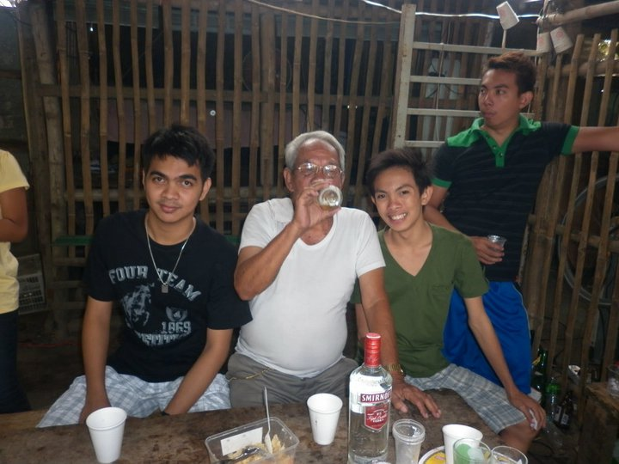**CURRICULUM VITAE**

**BONDOC, EDSAR ADRIANO**

Calle Ines, San Nicolas Poblacion,

Concepcion , Tarlac

(+63) 9156412283

redumalanta@ama.edu.ph

**EDUCATION**

1996 – 2001 **Minane Elementary School**

San Nicolas Poblacion, Concepcion, Tarlac

2001 – 2005 **Benigno S. Aquino National High School**

San Nicolas Poblacion, Concepcion, Tarlac

2005 – 2007 **AMA Computer Learning Center**

Sto Cristo, Tarlac, Tarlac City

Computer System and Network Technology

2008 – present **AMA Computer University**

AMA Computer College Tarlac Campus

Bachelor of Science in Information Technology

*Major in Web Development*

**CERTIFICATIONS**

**Computer Hardware Servicing NC II**

April 08, 2010

**WORK EXPERIENCE/ON-THE-JOB TRAINING**

**On-The-Job Training**

July 2010 – October 2010

Tarlac First Baptist Church School, Inc.

Romulo Blvd. cor. Ramos St., San Vicente, Tarlac City

**PERSONAL DATA**

Date of Birth : 25 February 1989

Place of Birth : Capas, Tarlac

Height : 5 ft 8 in

Weight : 132 lbs

Civil Status : Single

Religion : Roman Catholic

**CURRICULUM VITAE**

**BONDOC, JOHN PATRICK MATIAS**

Celestino St. San Jose

Concepcion, Tarlac

(+63) 9172448106

toggle_1221@yahoo.com

**EDUCATION**

1997 – 2003 **Concepcion South Elementary School**

San Jose Concepcion, Tarlac

2003 – 2007 **Benigno S. Aquino National High School**

Malacampa, Camiling, Tarlac

2007 – present **AMA Computer University**

AMA Computer College Tarlac Campus

Bachelor of Science in Information Technology

**PERSONAL DATA**

Date of Birth : 12 July 1991

Place of Birth : Concepcion, Tarlac

Height : 5 ft 7 in

Weight : 136 lbs

Civil Status : Single

Religion : Roman Catholic

**CERTIFICATIONS**

**Microsoft Certified Professional**

Installing, Configuring and Administering Microsoft XP Professional

September 14, 2010

**WORK EXPERIENCE/ON-THE-JOB TRAINING**

**On-The-Job Training**

July 2010 – October 2010

Tarlac First Baptist Church School, Inc.

Romulo Blvd. cor. Ramos St., San Vicente, Tarlac City